MIT Assignment-08

Jeetu Mehra
U24AI032

Q1.Write a program to add the following data bytes stored in memory locations starting at XX60H and display the sum at the output port if the sum does not generate a carry. If a result generates a carry, stop the addition, and display 01H at the output port.
Data (H):
First Set: 37, A2, 14, 78, 97
Second Set: 12, 1B, 39, 42, 07
LXI H, 2660H

MVI M, 37H
INX H
MVI M, 0A2H
INX H
MVI M, 14H
INX H
MVI M, 78H
INX H
MVI M, 97H
INX H
MVI M, 12H
INX H
MVI M, 1BH
INX H
MVI M, 39H
INX H
MVI M, 42H
INX H
MVI M, 07H

; -------- ADD LOGIC --------
LXI H, 2660H
MVI B, 0AH
MVI A, 00H

LOOP: ADD M
JC CARRY
INX H

DCR B
JNZ LOOP

OUT 01H
HLT

CARRY: MVI A, 01H
OUT 01H
HLT
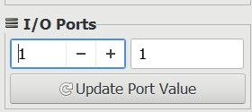

Q2.In Assignment 20, modify the program to count the number of data bytes that have been added and display the count at the second output port.
LXI H, 2660H

MVI M, 37H
INX H
MVI M, 0A2H
INX H
MVI M, 14H
INX H
MVI M, 78H
INX H
MVI M, 97H
INX H
MVI M, 12H
INX H
MVI M, 1BH
INX H
MVI M, 39H
INX H
MVI M, 42H
INX H
MVI M, 07H

; -------- ADD + COUNT --------
LXI H, 2660H
MVI B, 0AH
MVI A, 00H
MVI C, 00H

LOOP: ADD M
JC CARRY
INR C
INX H
DCR B
JNZ LOOP

OUT 01H
MOV A, C
OUT 02H
HLT

CARRY: MVI A, 01H
OUT 01H
MOV A, C

OUT 02H

HLT
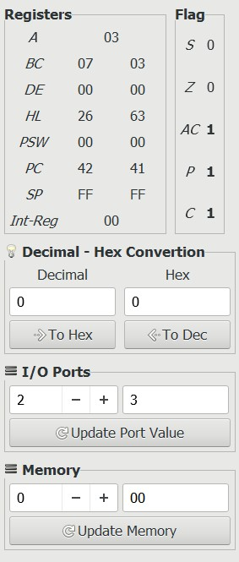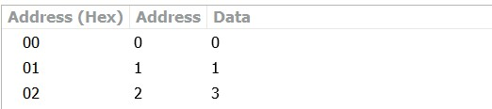

Q3.The temperatures of two furnaces are being monitored by a microcomputer. A set of five readings of the first furnace, recorded by five thermal sensors, is stored at the memory location starting at XX50H. A corresponding set of five readings from the second furnace is stored at the memory location starting at XX60H. Each reading from the first set is expected to be higher than the corresponding reading from the second set. For example, the temperature reading at location 54H (T₅₄) is expected to be higher than the temperature reading at location 64H (T₆₄). Write a program to check whether each reading from the first set is higher than the corresponding reading from the second set.
- If all readings from the first set are higher → turn ON bit D₀ of output PORT1
- If any one reading is lower → stop and output FF at PORT1 (emergency signal)
Data (H):
First Set: 82, 89, 78, 8A, 8F
Second Set: 71, 78, 79, 82, 7F
LXI H, 2650H
MVI M, 45H
INX H
MVI M, 50H
INX H
MVI M, 60H
INX H
MVI M, 70H
INX H
MVI M, 80H

; -------- STORE SECOND SET --------
LXI H, 2660H
MVI M, 30H
INX H
MVI M, 40H
INX H
MVI M, 55H
INX H
MVI M, 65H
INX H
MVI M, 75H

; -------- COMPARISON --------
LXI H, 2650H
LXI D, 2660H
MVI B, 05H

LOOP: MOV A, M
MOV C, A

LDAX D
CMP C
JNC FAIL

INX H
INX D
DCR B
JNZ LOOP

MVI A, 01H
OUT 01H
HLT

FAIL: MVI A, 0FFH
OUT 01H
HLT
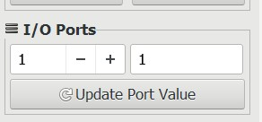

Q4.A set of eight data bytes is stored in memory locations starting from XX70H.
Write a program to subtract two bytes at a time and store the result in a sequential order in memory locations starting from XX70H.
Data (H):
F9, 38, A7, 56, 98, A2, F4, 67
LXI H, 2670H

MVI M, 0F9H
INX H
MVI M, 38H
INX H
MVI M, 0A7H
INX H
MVI M, 56H
INX H
MVI M, 98H
INX H
MVI M, 0A2H
INX H
MVI M, 0F4H
INX H
MVI M, 67H

; -------- SUBTRACTION --------
LXI H,2670H
LXI D,2670H
MVI C,04H
LOOP: MOV A,M
INX H
MOV B,M

SUB B

STAX D

INX D INX H

DCR C
JNZ LOOP
HLT
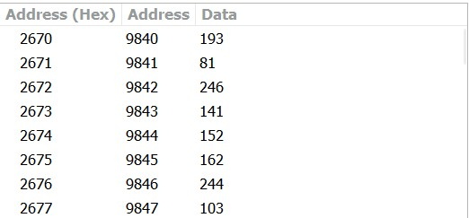

Q5.A set of eight data bytes is stored in the memory location starting at XX50H. Check each data byte for bits D₇ and D₀.
- If D₇ or D₀ is 1 → reject the data byte
- Otherwise → store the data bytes at memory locations starting at XX60H
Data (H):
80, 52, E8, 78, F2, 67, 35, 62
; Assume XX = 20 → so addresses are 2050H and 2060H

LXI H, 2650H ; Point to source memory

MVI A, 80H
MOV M, A
INX H

MVI A, 52H
MOV M, A
INX H
MVI A, 0E8H
MOV M, A
INX H

MVI A, 78H
MOV M, A
INX H

MVI A, 0F2H
MOV M, A
INX H

MVI A, 67H
MOV M, A
INX H

MVI A, 35H
MOV M, A
INX H

MVI A, 62H
MOV M, A

LXI H, 2650H ; Source pointer
LXI D, 2660H ; Destination pointer
MVI C, 08H ; Counter

LOOP: MOV A, M ; Load data byte

ANI 81H ; Check D7 and D0
JNZ SKIP ; If either is 1 → reject MOV A, M ; Reload original data
STAX D ; Store at destination
INX D ; Increment destination pointer

SKIP: INX H ; Next source byte
DCR C
JNZ LOOP

HLT
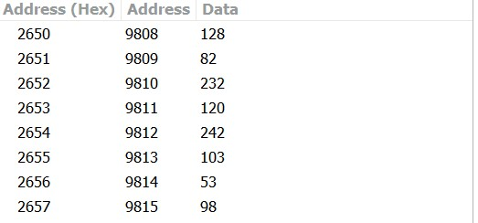

Q6.A microcomputer is designed to control various appliances and lights in your house.
The system has an output port with address 01H, and various units are connected to bits D₇ to D₀.
On a cool morning you want to turn ON:
- Radio
- Coffeepot
- Space heater
Write appropriate instructions for the microcomputer. Assume R/W memory begins at 2000H.

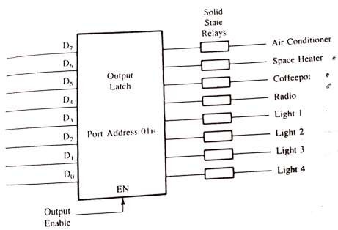

LXI SP, 2099H ; Initialize Stack Pointer
MVI A, 70H ; Load 70H (Radio + Coffeepot + Space Heater ON)
OUT 01H ; Send to Output Port 01H
HLT ; Stop
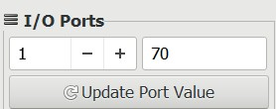
An additional input port with eight switches and address 01H is connected to the microcomputer to control the same appliances and lights from both bedroom and kitchen.
Write instructions to turn ON devices from any of the input ports.

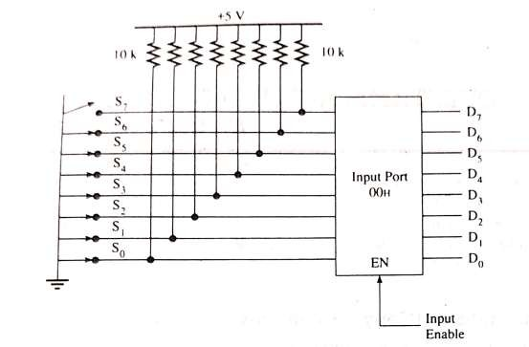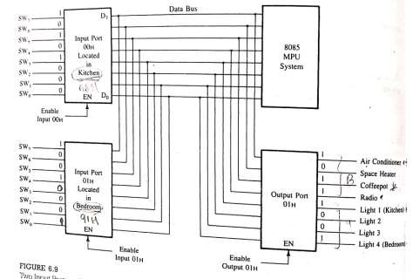

LXI SP, 2099H ; Initialize Stack Pointer

IN 00H ; Read Kitchen Input Port (00H) into Accumulator
MOV B, A ; Save kitchen input in register B

IN 01H ; Read Bedroom Input Port (01H) into Accumulator
ORA B ; OR bedroom with kitchen inputs
; (device ON if either port requests it)

OUT 01H ; Send combined result to Output Port 01H
HLT ; Stop
```

---

## Explanation of Logic
```
Kitchen (00H): 1 0 1 0 0 1 0 1 → A5H
Bedroom (01H): 1 0 0 1 0 0 0 1 → 91H
OR Result : 1 0 1 1 0 1 0 1 → B5H
↑ ↑ ↑
A/C Coffepot+Radio ON from either room
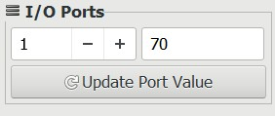

Q7.If the switch S₇ of input PORT0 (connected to data line D₇) is at logic 1 and all other switches are at logic 0, specify the contents of the accumulator when the instruction IN PORT0 is executed.

MVI A, 9FH
IN PORT0
MOV B, A
OUT PORT1
HLT

Accumulator (A) = 80H Explanation:
Only switch S7 is ON, so D7 = 1 and all other bits are 0.
So input from PORT0 = 10000000 = 80H.
When IN PORT0 is executed, accumulator gets this value. Hence A = 80H.

Q8.Specify the output at PORT1 and the contents of register B after executing the instructions in Assignment 6.
PORT1 = 80H
Register B = 80H Explanation:
From Q6, input from PORT0 = 80H (only D7 = 1).
IN PORT0 loads A = 80H.
MOV B, A copies A to B, so B = 80H.
OUT PORT1 sends A to PORT1, so PORT1 = 80H.

